TOY BOX NEWSLETTER
April 2017
Spring term
Dear Parents/Carers,

Welcome to all new parents and children. Here are a few reminders and events that are coming up over the next few weeks.
Many thanks for all your support.
Mobile phones
Toy box has a ‘no mobile phone policy’. This policy is in place to safeguard the children.
Please do not use your phone while inside the building.
Thank you
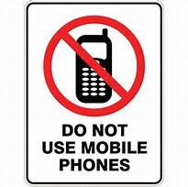

The Toy Box Team
At Toy Box we track your child’s progress by taking observations through a program called Tapestry and this is going really well.
Please remember you can also add comments and special events to let us know what your child has been doing at home.
Please let us know how you get on and if we can offer any further help.

Absences and Holidays
If you are going away on holiday or if your child has an illness, please could you let a member of staff know or give us a telephone call on 01724 857126.

Opening and closing
Just a reminder that Toy Box will be closed for the bank holidays on Friday 14th and Monday 17th April.
For children who attend term time only
At Easter, the last day is Friday 7th April and will return on Tuesday 25th April.
Reminders
Please could you label your child’s bags, wellies and coats as we have children coming in to Toy Box with the same items.
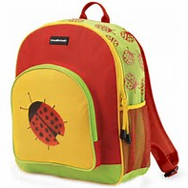

30 hours funding
30 hours will be coming into effect from September 2017 for 3 and 4 year olds.
Working parents must apply for this funding and you will then be given a code to pass on to us. For more information please go to www.gov.uk or contact 0300 123 4097.
The introduction of the government’s Tax-Free childcare scheme will begin on 28th April.
Please visit www.childcarechoices.gov.uk for more information.
Potty training
Here are a few potty training tips if you think your child is ready.
Encourage your child to sit on the potty after meals, because digesting food often leads to an urge to do a poo. Having a book to look at or toys to play with can help your child sit still on the potty. If your child regularly does a poo at the same time each day, leave their nappy off and suggest that they go in the potty. If your child is even the slightest bit upset by the idea, just put the nappy back on and leave it a few more weeks before trying again. If you don't make a fuss when they have an accident, they won't feel anxious and worried, and are more likely to be successful the next time. Dress them in clothes that are easy to change and avoid tights, skinny jeans and clothes with zips or lots of buttons.

It would be much appreciated if parents/carers could add some comments to the ‘chatter book’ about the Imagination Library books your child receives.
You can find the book hanging on the Imagination Library board in the reception to write your comments in. If it’s easier, you can email your comments and pictures and we will add them for you.
Our email address is info@thetoyboxnursery.co.uk
Illness and medication
Just a reminder if your child is off sick with diarrhoea or vomiting they should be kept away from the nursery until 48 hours from the last episode.

